**Project Title**

Laundry Service and Management (WashEase)

**Description**

In our laundry management web app, users effortlessly track previous orders, ensuring seamless reordering. They can also choose from a diverse range of trusted vendors offering specialized services like dry cleaning and ironing. Our platform prioritizes user convenience, choice, and quality.

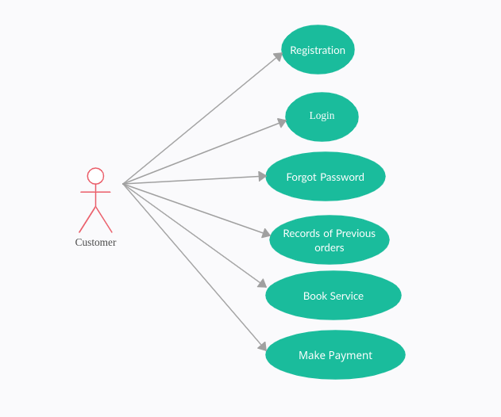

Vendor Diagram

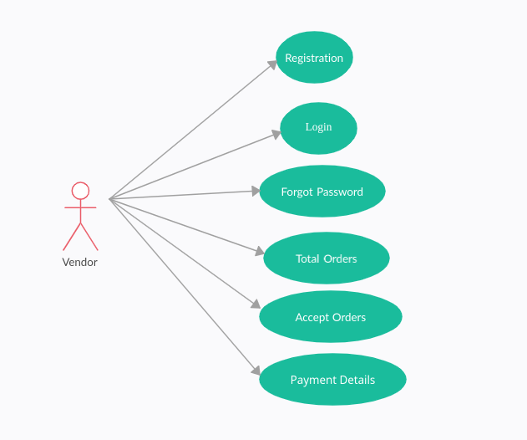

Admin Diagram

